**BackEnd**

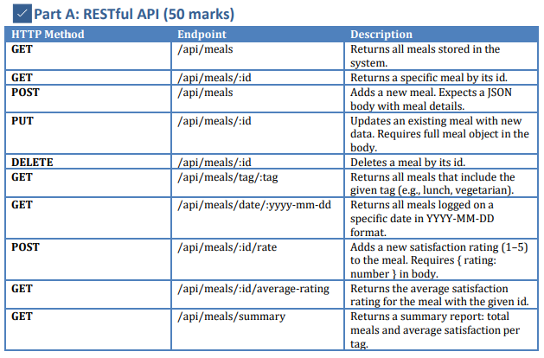

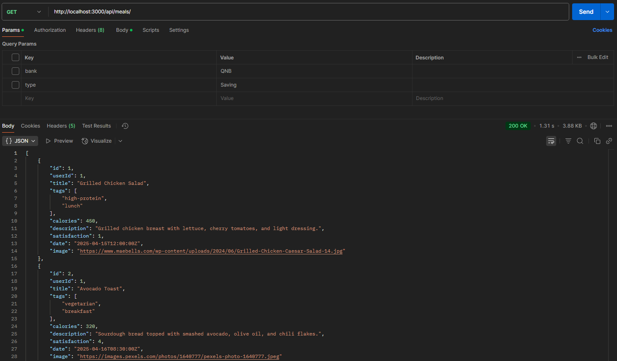

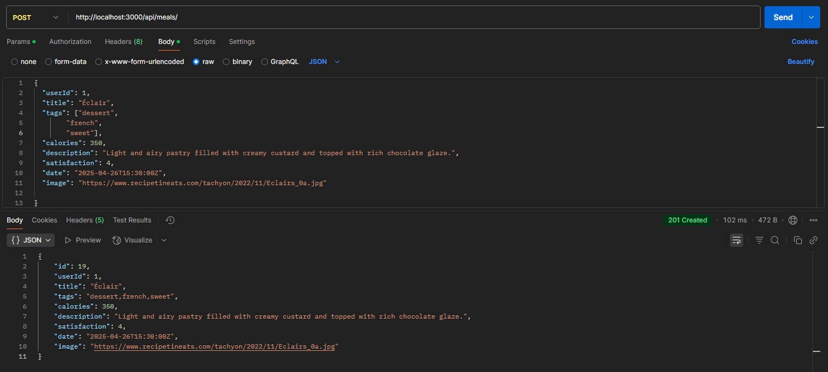 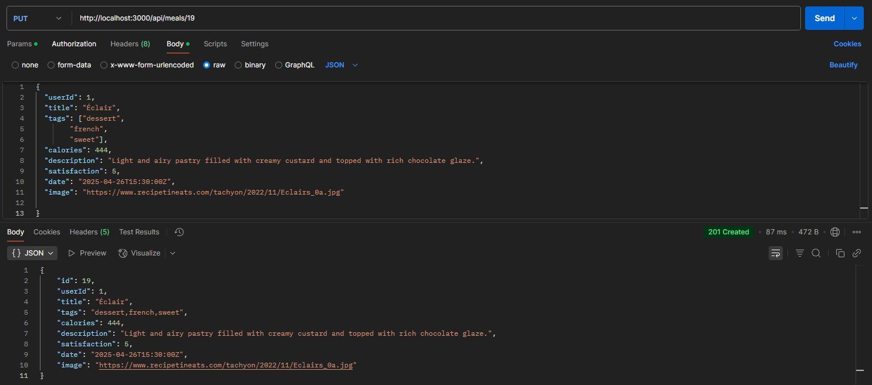

** 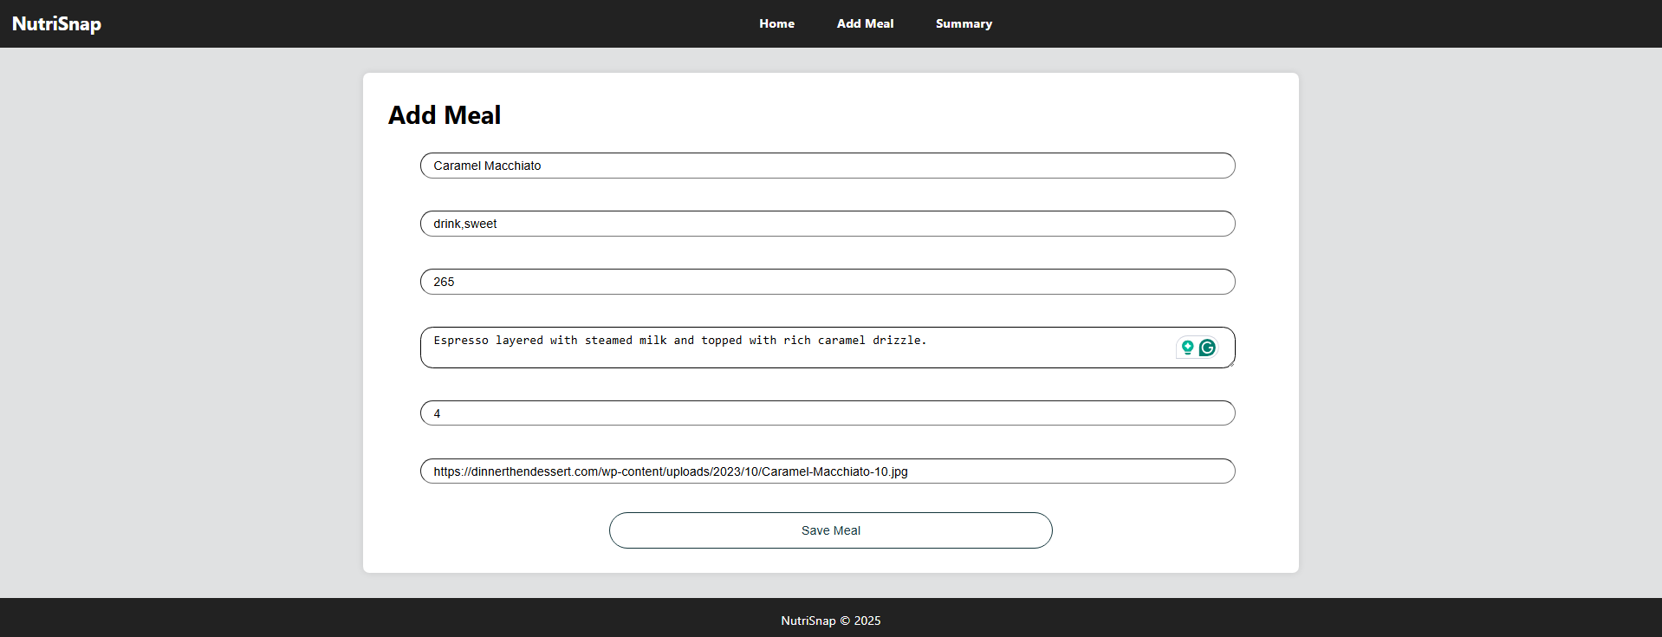 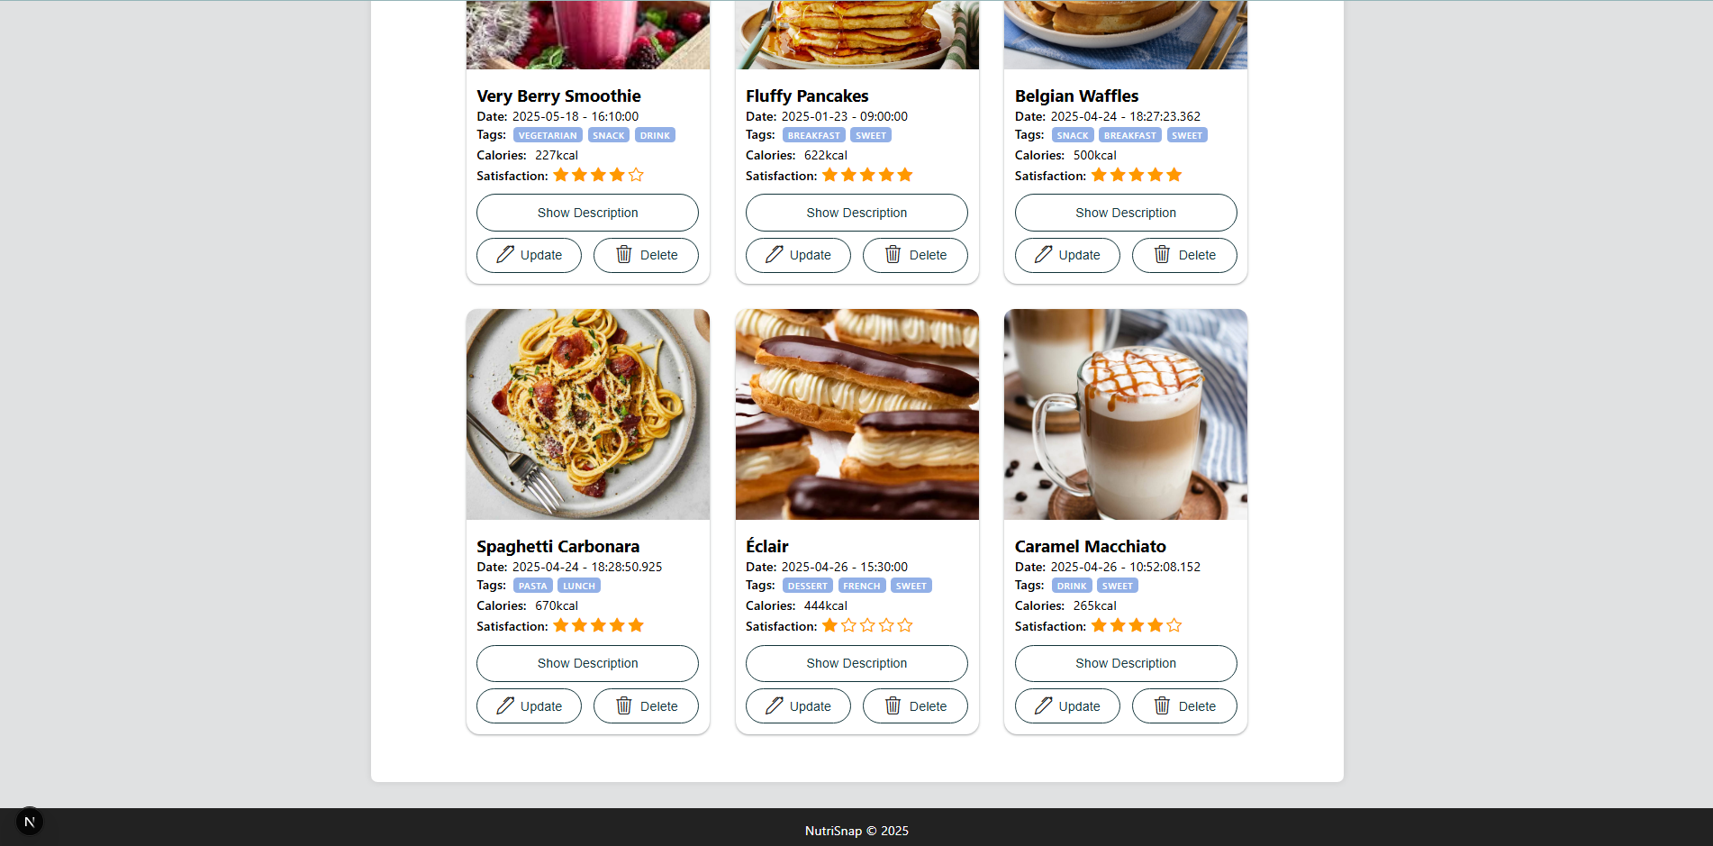 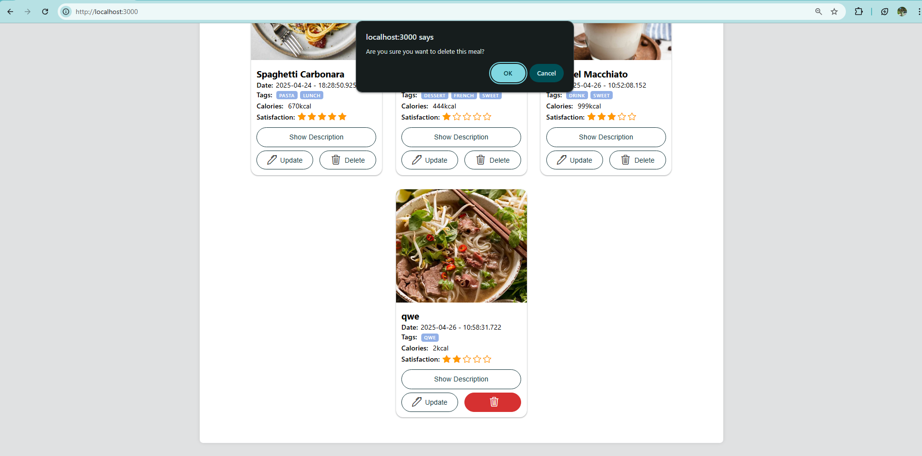

Toggle, Update, Delete and Add Rating By Clicking On Stars

